HIRETUAL DOCUMENTATION

**What is Hiretual**

Hiretual is recruiter’s best friend. Technology built by recruiters for recruiters is assisting with boolean building and providing 24/7 AI Sourcing that makes your life easier.

Search across 20+ platforms including FB, Github, LI, Indeed and more. With the power of quickly generating shortlists and finding accurate contact information and professional analytics, your sourcing and recruiting becomes 10x faster.

**Features of Hiretual**

* Drive the sourcing AI assistant to work for you 24/7
* Search without limits across 20 different platforms
* Find contact from the biggest database in the world
* Refresh and augment old list with fresh data and analytics
* Make sourcing a team sport with collaboration, shared projects, and notes.
* Hiretual offers cross-platform searches that can obtain full resume

Step1:

Signup with Hiretual using <https://app.hiretual.com/signup>

Step 2:

In Discovery option we have 3 features to get person information,

* Smart Search
  + Boolean builder
    - Quick mode
    - Smart mode
    - Parse Resume
  + Facebook search
    - Keyword based
  + Github search
    - Talent based
    - Repository based
* Contact & Analysis
* AI Sourcing

Step3:

In Pipeline option,

* Add talent profiles using Hiretual Extension.



##### 1. Save talent profiles to Pipeline through Hiretual extension.

##### 2. Manage talent profiles on Pipeline page through hiretual.com.

#### Bulk import talent profiles to Pipeline.

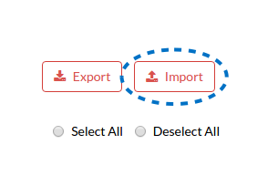

##### 1. Prepare a CSV file based on Hiretual instructions.

##### 2. Import a CSV file and Hiretual will generate a pipeline for you.

Price Plan

* Cancel Anytime
* Hassle Free
* Satisfaction Guaranteed



|  |  |  |  |
| --- | --- | --- | --- |
| Features | Free | Premium | Pro |
| Contacts | **10**/week | **200**/month | **Custom** |
| Profile Analysis | **30**/week | **600**/month | **Custom** |
| Project Management | **2 projects** | **Unlimited** | **Unlimited** |
| Boolean Builder Assistant | **YES** | **YES** | **YES** |
| X-Ray Search Assistant | **YES** | **YES** | **YES** |
| Social Aggregation | **YES** | **YES** | **YES** |
| Pipeline Management | **YES** | **YES** | **YES** |
| Chrome Extension | **YES** | **YES** | **YES** |
| Boolean String Bookmark/History | **-** | **YES** | **YES** |
| Data Export | **-** | **YES** | **YES** |
| Service Rollover | **-** | **YES** | **YES** |
| Priority Customer Service | **-** | **YES** | **YES** |
| AI Sourcing | **-** | **-** | **YES** |
| Data/List Augmentation & Refreshment | **-** | **-** | **YES** |
| Team Collaboration | **-** | **-** | **YES** |
| ATS/CRM Integration | **-** | **-** | **YES** |
| Performance & Reports | **-** | **-** | **YES** |
| On-boarding Training | **-** | **-** | **YES** |
| Shared Service Credits | **-** | **-** | **YES** |

Demo

Smart Search – Repository search from Github

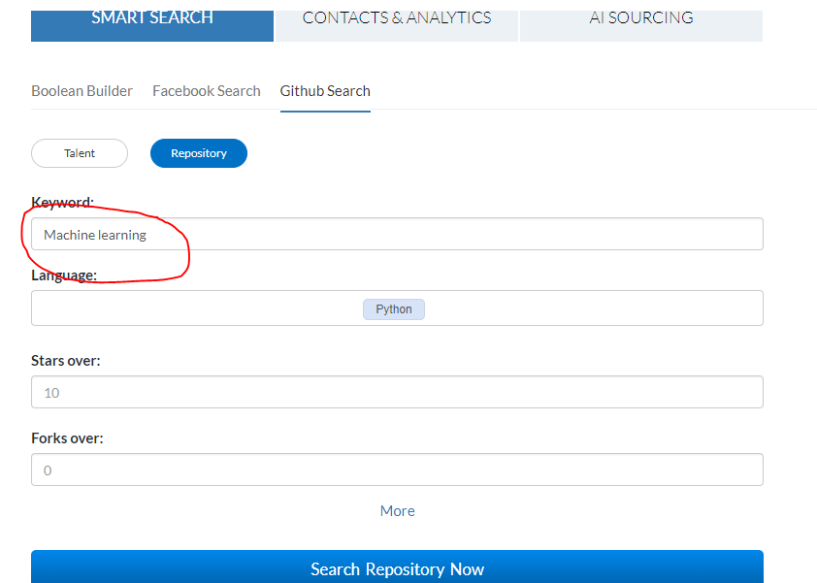

Result

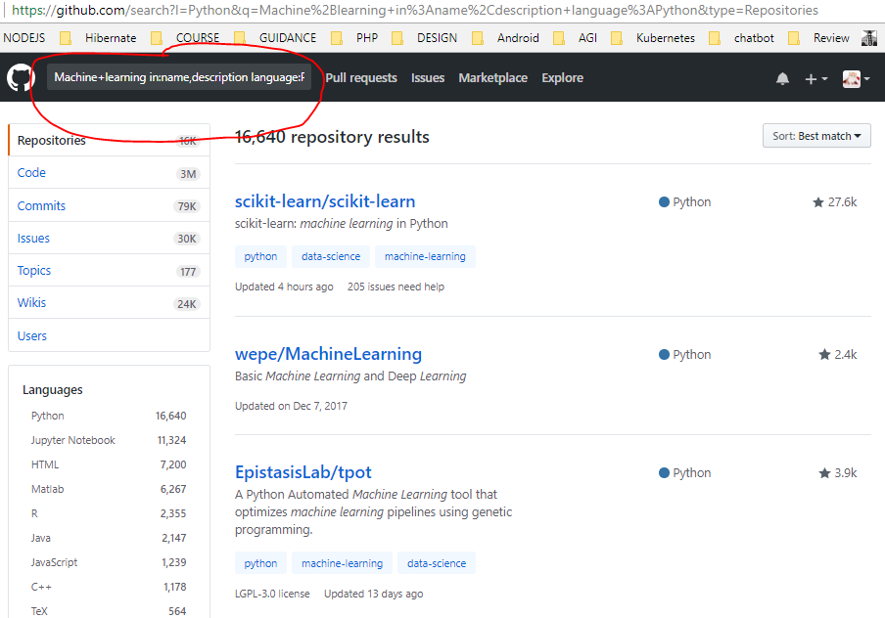

Contact & Analysis

* + Name of contact
  + Location

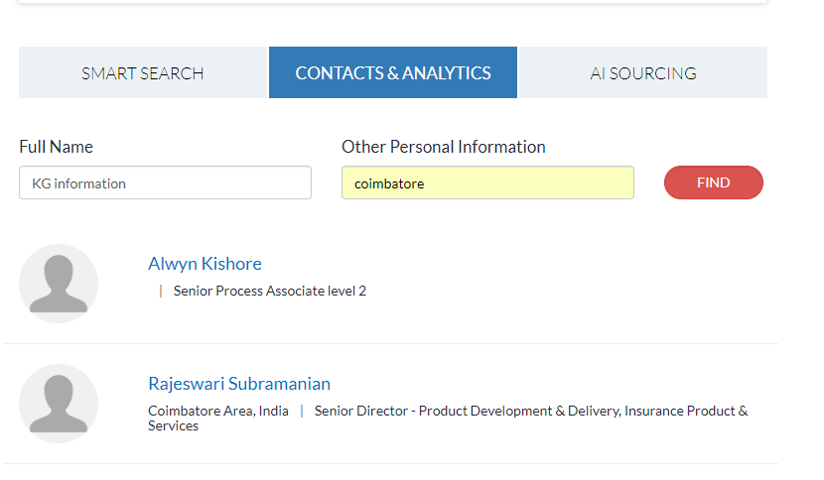

Smart search – Using Boolean builder – Smart mode

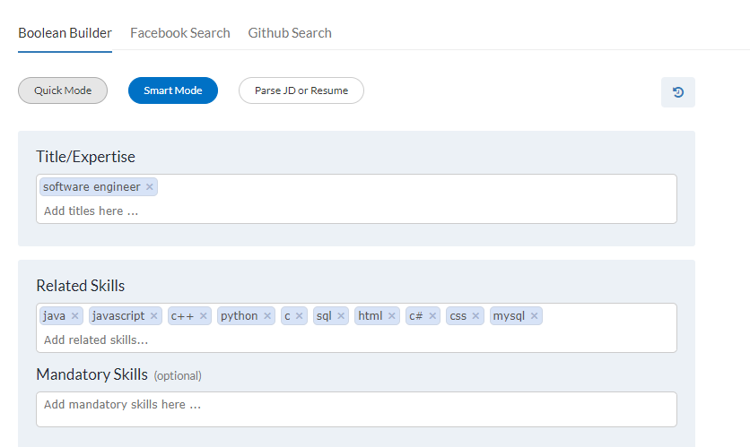

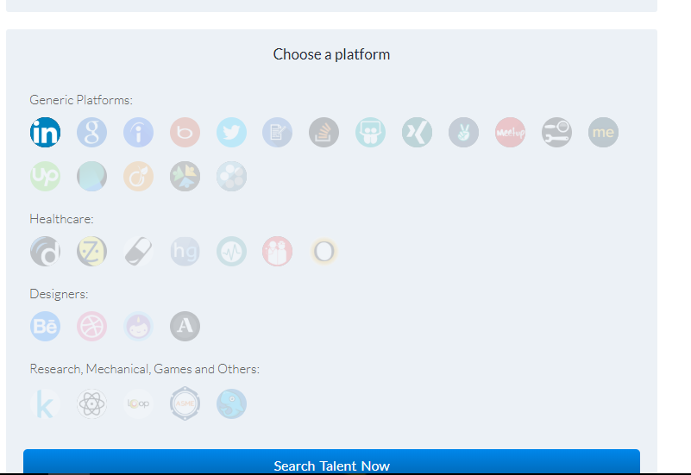

Result

